Alec Day

My style:

I would say that my style is hard-working and team-oriented. I am a hard worker when it comes to anything that I involve myself in. I always try my best to do things with 100% effort and do them the right way as well. If a project is not done a specific way, I will keep working until it is the way I like the way it turns out. This also applies to my group mentality. I work best when I am in a team, and most often I assume a leadership role within that group when there is not a designated leader present. I can also work well in a group as a team member and will follow directions from the group and the leader to the best of my ability.

What I value:

I value a hard work ethic, as well as, people who have goals. Without a goal in mind, we usually have no purpose in our work. This ultimately leads to being lax and idle in our projects. When we do have a goal in mind and are actively working to achieve that goal, we have a purpose. This is easy to see in someone because it is reflected in their work ethic. If they’re lax, they probably don’t have any goals or are not putting effort towards them. Likewise, if they’re hardworking, they have a goal.

What I don't have patience for:

I don’t have patience for procrastinators or people with low work ethics. If it wasn’t already obvious, I like people that work hard. I can’t understand why some people go half way on anything.

How best to communicate with me:

Be direct with me and do not sugar coat anything. If there’s something that’s needed to be said, say it. Don’t worry about “hurting my feelings”, I will understand and change to whatever is needed of me.

How to help me:

Reach out to me and ask me for updates on what I have been doing. This will help me evaluate what I have been doing and what I have accomplished. It will also help me understand what I still need to do.

What people misunderstand about me:

A lot of people see me and think I am not as smart as I actually am. I’m not trying to be arrogant, I think a lot of people see me and don’t think I would be a software engineer based on my appearance, and then infer I am some dumb muscle head. I feel like I embody a lot of the skills that are needed to become a successful engineer. Those skills are hard-working, goal-oriented, and the desire to learn new things.

Health:

* I would say that I am a pretty healthy person. I eat well and I work out almost every day.
* Full
* I would like to try to eat healthier, but it’s expensive
* I would say that this problem is not a gravity problem.

Work:

* Work-wise I am also doing really well. I have 2 jobs that I am working, and I can manage my schedule really well around them
* Full
* I would like to have more free time and not always be working
* I actually just got some shifts changed, so now I can sleep in on Monday, Wednesday, and Fridays

Play:

* I do enjoy playing video games at the end of a long day to destress and relax. I also like going on hikes on the weekends to clear my head.
* ¾
* I wish I enjoyed activities that weren’t so expensive
* This is a gravity problem, I could easily find new cheaper hobbies

Love:

* I am in a pretty serious relationship right now with someone I plan on marrying. I am just not sure yet if I want to spend eternity with them
* ¾
* I need to know if they’re “the one”
* This is not a big problem, I just need to take my time and be sure and confident.

Workview:

I work in order to keep myself afloat financially. I need to be able to provide for my needs. These include; food, water, rent, gas, etc. They also help pay for the hobbies that I enjoy. I work to live essentially. In the future, I will continue to work so my children can enjoy childhood, and so I can provide for my family well enough that they don’t have to worry about money. I think through this, I will be fulfilled if I can achieve happiness with my future family.

Lifeview:

The obvious answer is that we are here on earth in order to have families and be happy in those families. We find meaning in life as we accomplish goals that we set for ourselves, and obtain knowledge and wisdom through the holy spirit. For myself, I find purpose every day when I help others, work, and learn. To be good is to follow God, do the right thing, and seek the truth. Evil is the opposite of this. Our lives are not our own, they’re God’s gift to us, and we need to reciprocate our appreciation for our lives, by following him and keeping the covenants we have made with him.

Combination of Work and Life:

* I believe that they complement each other. They wouldn’t exist without the other. We exist to work for God, and we need to work temporally in order to provide for the needs of life. They are codependent.

Good Time Journal:

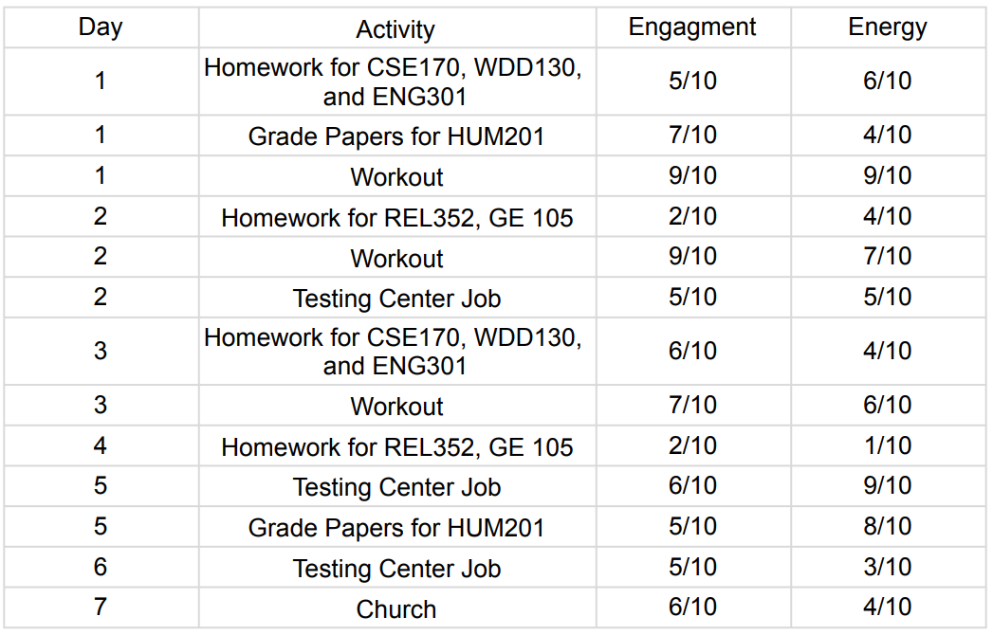

* I noticed that I have more energy doing things that I enjoy doing, compared to what I experienced when I did things that I don’t like doing as much. For the most part, the engagement for each activity was constant.

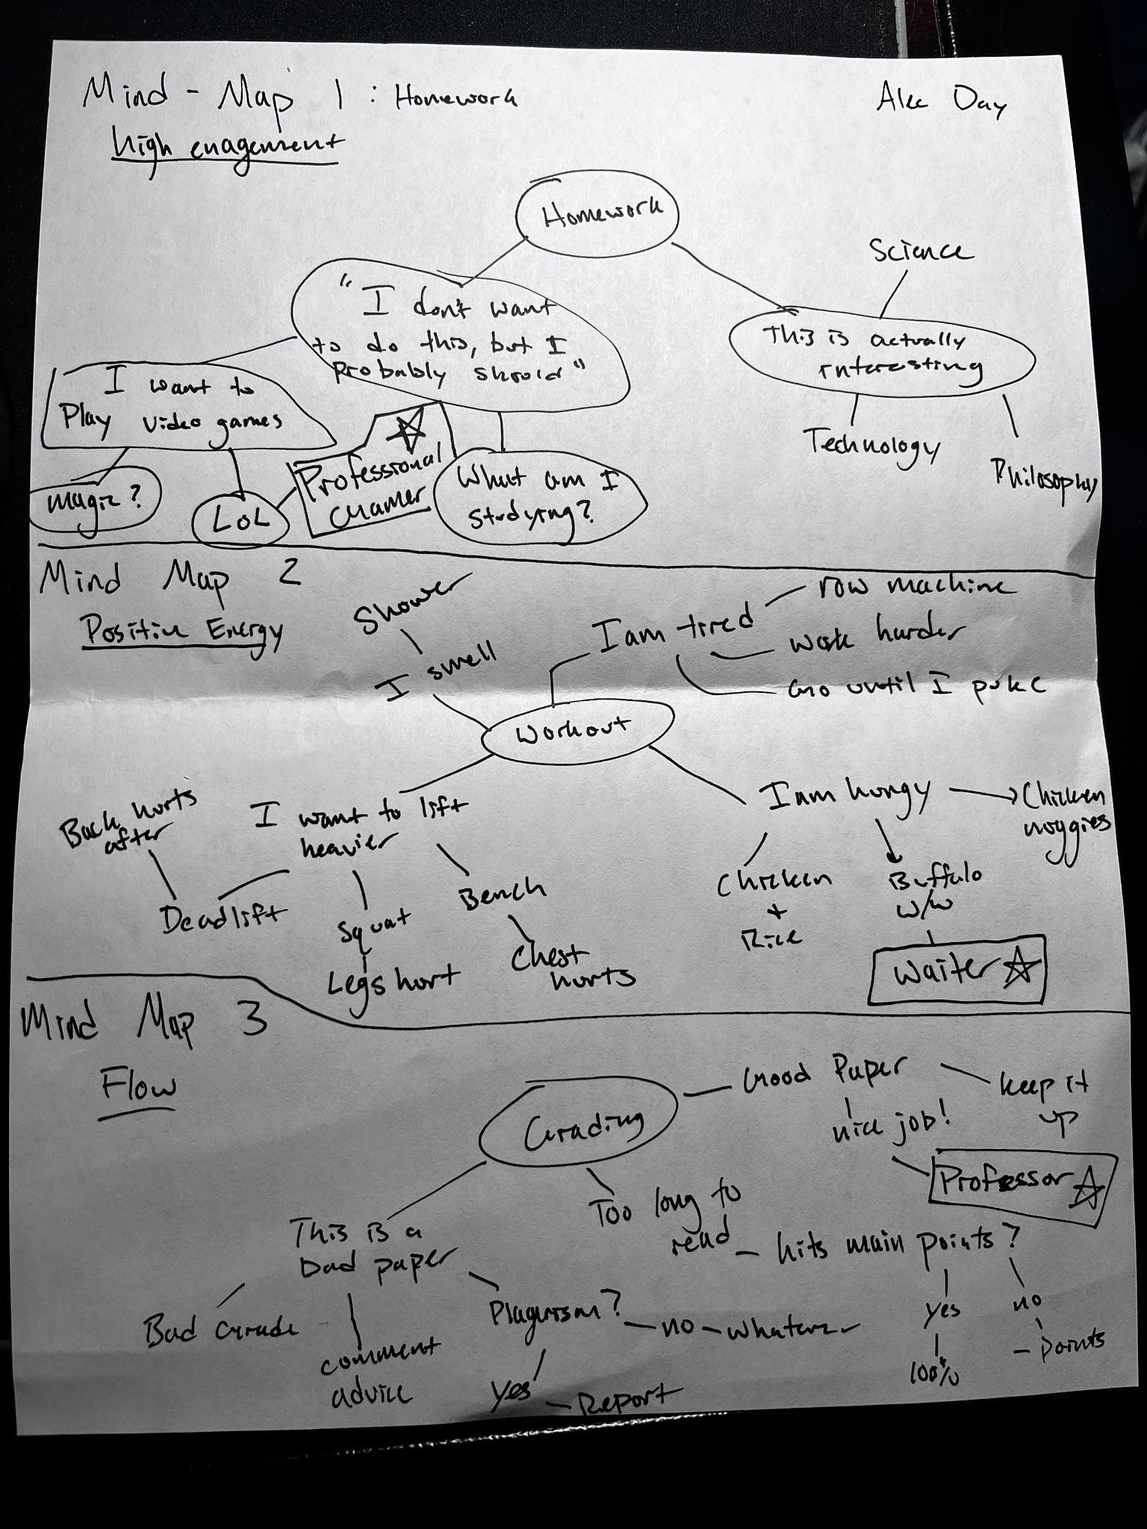Mind Map:

Odyssey Plans:

Plan 1:

Year 1:

* Continue working and studying at BYUI
* Start a Personal Project related to ML or AI
* Join the AI society
* Get Married

Year 2:

* Repeat Year 1 Studying and Working
* Participate in Hack-a-thons
* Internship

Year 3:

* Apply for Graduate School (get in)
* Graduate
* Continue job at the internship
* Have a kid

Year 4:

* Graduate School
* Continue Working

Year 5:

* Finish Graduate School
* Find a Stable job
* Relocate to the east coast if not already there

Plan 2: (Graduate school fails)

Year 1 and 2:

* Same thing as described in Plan 1

Year 3:

* Get a Job
* Have a Kid
* Graduate

Year 4:

* Relocate to the east coast
* Have another kid

Year 5:

* Get a Promotion
* Buy a Boat

Plan 3:

Year 1:

* See plan 1

Year 2:

* See Plan 1

Year 3:

* Graduate
* Get a job
* Buy a lot of real estate
* Move to the east coast
* Open a music store

Year 4:

* Solely work at a music store
* Open a restaurant
* Buy stocks

Year 5:

* Buy another house
* Get a summer home in Florida along the gulf of Mexico
* Play a lot of golf